SmartSteth: A Convolutional Neural Network (CNN) Driven Auscultation Instrument Using Lung Sound Analysis for Early Respiratory Disease
Detection in Satellite Clinics

Kiesha Mekhaela B. Relatado, Ahnycca Krish N. Malimban, Teokislev Gazelle J. Jompella
Science, Technology, Engineering, and Mathematics – Senior High School Department
Puerto Princesa City National Science High School, Palawan

Abstract—After finishing research and experimentation, you are required to write a (maximum) 250 word, one-page abstract. It is recommended that it include the following: (a. purpose of the experiment, b. procedure, c. data, d. conclusions). It may also include any possible research applications. Only minimal reference to previous work may be included. An abstract must not include the following: a.) acknowledgments (including naming the research institution and/or mentor with which you were working), or self-promotions and external endorsements, b.) work or procedures done by the mentor DO NOT USE SPECIAL CHARACTERS, SYMBOLS, OR MATH IN YOUR TITLE OR ABSTRACT. (Abstract)
Keywords—key words

INTRODUCTION
In the rural barangays of Puerto Princesa City, access to timely and accurate healthcare remains a persistent challenge. Geographic isolation, limited medical personnel, and outdated diagnostic tools hinder early detection and treatment especially for respiratory illnesses that disproportionately affect children, the elderly, and other vulnerable groups. Health workers, often operating with minimal resources, rely on manual auscultation and subjective clinical judgment, which can lead to misdiagnosis, underreporting, and preventable complications.
Among the most common and concerning respiratory conditions in these communities are pneumonia, bronchiolitis, and asthma. Pneumonia, a serious lung infection, remains a leading cause of mortality in the Philippines. Between January and October 2023, the Department of Health recorded 158,762 pneumonia cases, a 45.68% increase compared to the same period in 2022 (Philstar.com, 2023). In 2024, pneumonia became the fourth leading cause of death nationwide, surpassing diabetes mellitus, with 46,718 reported fatalities (BusinessMirror, 2024). Bronchiolitis, primarily caused by respiratory syncytial virus (RSV), is a leading cause of hospitalization among infants. Although rural-specific data is limited, the disease burden is significant nationwide, and early detection remains critical in areas with limited healthcare access. Asthma, a chronic inflammatory disease of the airways, is frequently underdiagnosed and poorly managed in rural settings. A retrospective cohort study in a rural Philippine site revealed that while 93.3% of children with asthma were prescribed short-acting beta-agonists, only 5.8% received inhaled corticosteroids highlighting a gap in optimal treatment access (PubMed, 2024). Environmental exposures and healthcare access also influence asthma symptoms, with rural residents often experiencing less severe symptoms than their urban counterparts (MIMS, 2023).
These challenges inspired the development of SmartSteth, an AI-powered auscultation device designed to assist frontline health workers in the early identification of lower respiratory tract diseases. By integrating convolutional neural network (CNN) technology with traditional stethoscope functionality, SmartSteth enhances the diagnostic capabilities of health workers without requiring extensive training or technical expertise. The device analyzes lung sounds in real time, providing immediate, data-driven insights that support early identification of respiratory conditions. Its compact form factor and offline functionality make it especially suitable for barangay health stations, mobile clinics, and home visits settings where electricity, internet connectivity, and laboratory support are often unreliable or unavailable.
SmartSteth is designed with the end user in mind. Health workers in remote areas frequently juggle multiple roles, from triage to treatment to data reporting, often under time pressure and with limited supervision. The device’s intuitive interface, automated analysis, and visual feedback reduce cognitive load and improve confidence in clinical decision-making. It also facilitates better communication with patients and caregivers by translating complex auscultation findings into understandable results. These features not only improve diagnostic accuracy but also strengthen trust between health workers and the communities they serve.
From a market perspective, SmartSteth addresses a critical gap in the global health technology landscape: the need for affordable, scalable diagnostic tools tailored to low-resource settings. As governments, NGOs, and health systems increasingly prioritize digital transformation and universal health coverage, there is growing demand for innovations that combine clinical impact with operational simplicity. SmartSteth’s modular design and potential for integration with electronic medical records, telemedicine platforms, and community health programs position it as a versatile solution with strong commercial and public health appeal. Its deployment could catalyze broader improvements in respiratory care, data collection, and disease surveillance across underserved regions.
This study aimed to:
- Evaluate SmartSteth’s diagnostic accuracy and usability in rural healthcare settings
- Understand health worker experiences and community perceptions of AI-assisted screening
- Identify user-driven design improvements to enhance adoption and effectiveness
- Explore pathways for market integration and scale-up in remote communities
Without intervention, delayed diagnosis of respiratory illnesses may worsen poverty, strain local health systems, and increase preventable deaths. As highlighted by recent studies and public health reports, strengthening healthcare infrastructure and access in rural areas is essential to addressing the rising burden of respiratory diseases (BusinessMirror, 2023; PubMed, 2024; Philstar.com, 2023). By promoting accessible, tech-enabled screening, this study contributes to key United Nations Sustainable Development Goals (UNSDGs), including Goal 3 (Good Health and Well-being), Goal 9 (Industry, Innovation and Infrastructure), Goal 10 (Reduced Inequalities), and Goal 17 (Partnerships for the Goals). Ultimately, SmartSteth seeks to bridge the gap between innovation and inclusion—empowering health workers and improving respiratory care where it’s needed most.
MATERIALS AND METHODS

Gathering Lung Sound Dataset

Requirements Gathering

Training of Artificial Intelligence

Assembling of the Device

Web Development

Artificial Intelligence Integration

Device Finalization
Figure 1. Schematic Diagram

Gathering Lung Sound Dataset
The study involves collecting an accurate lung sound dataset, which is critical for training and validating the artificial intelligence model. The dataset consists of auscultated respiratory sounds, including recordings of normal breathing as well as sounds associated with lower respiratory tract diseases such as Asthma, Pneumonia, and Bronchiolitis. The lung sounds are captured using digital stethoscopes or high-quality MEMS microphones, ensuring clear audio signals with minimal noise interference. These recordings are organized and labeled accurately based on the patient's medical diagnosis to create a reliable dataset that will serve as the foundation for the AI classification model.

Requirements Gathering
The functional and technical specifications necessary to develop the respiratory sound classification system. This includes identifying the hardware components, such as the ESP32 microcontroller and INMP441 MEMS microphone, and defining the software requirements, including audio processing algorithms, web server dependencies, and AI model compatibility. Input from health professionals is considered to understand real-world needs, such as the ability to classify lung sounds quickly and accurately and display results in a user-friendly format. Additional considerations include Wi-Fi connectivity for data transmission, storage capabilities, security of patient data, and a clear interface for visualizing results

Training of Artificial Intelligence
Artificial intelligence training is a core component of the project. The labeled lung sound dataset is preprocessed to remove noise, normalize volume levels, and convert audio into a suitable format, such as Mel-spectrograms. These spectrograms are then uploaded and trained using Edge Impulse, a platform for building embedded machine learning models, where a Convolutional Neural Network (CNN) is employed to detect patterns in the lung sounds associated with different respiratory conditions. The model undergoes multiple sections of training and validation to optimize its performance, reduce overfitting, and improve accuracy. Learning rate, batch size, and number of false positives are carefully tuned to achieve reliable classification results. The final trained model is then ready to be deployed for real-time lung sound analysis.

Assembling of the Device
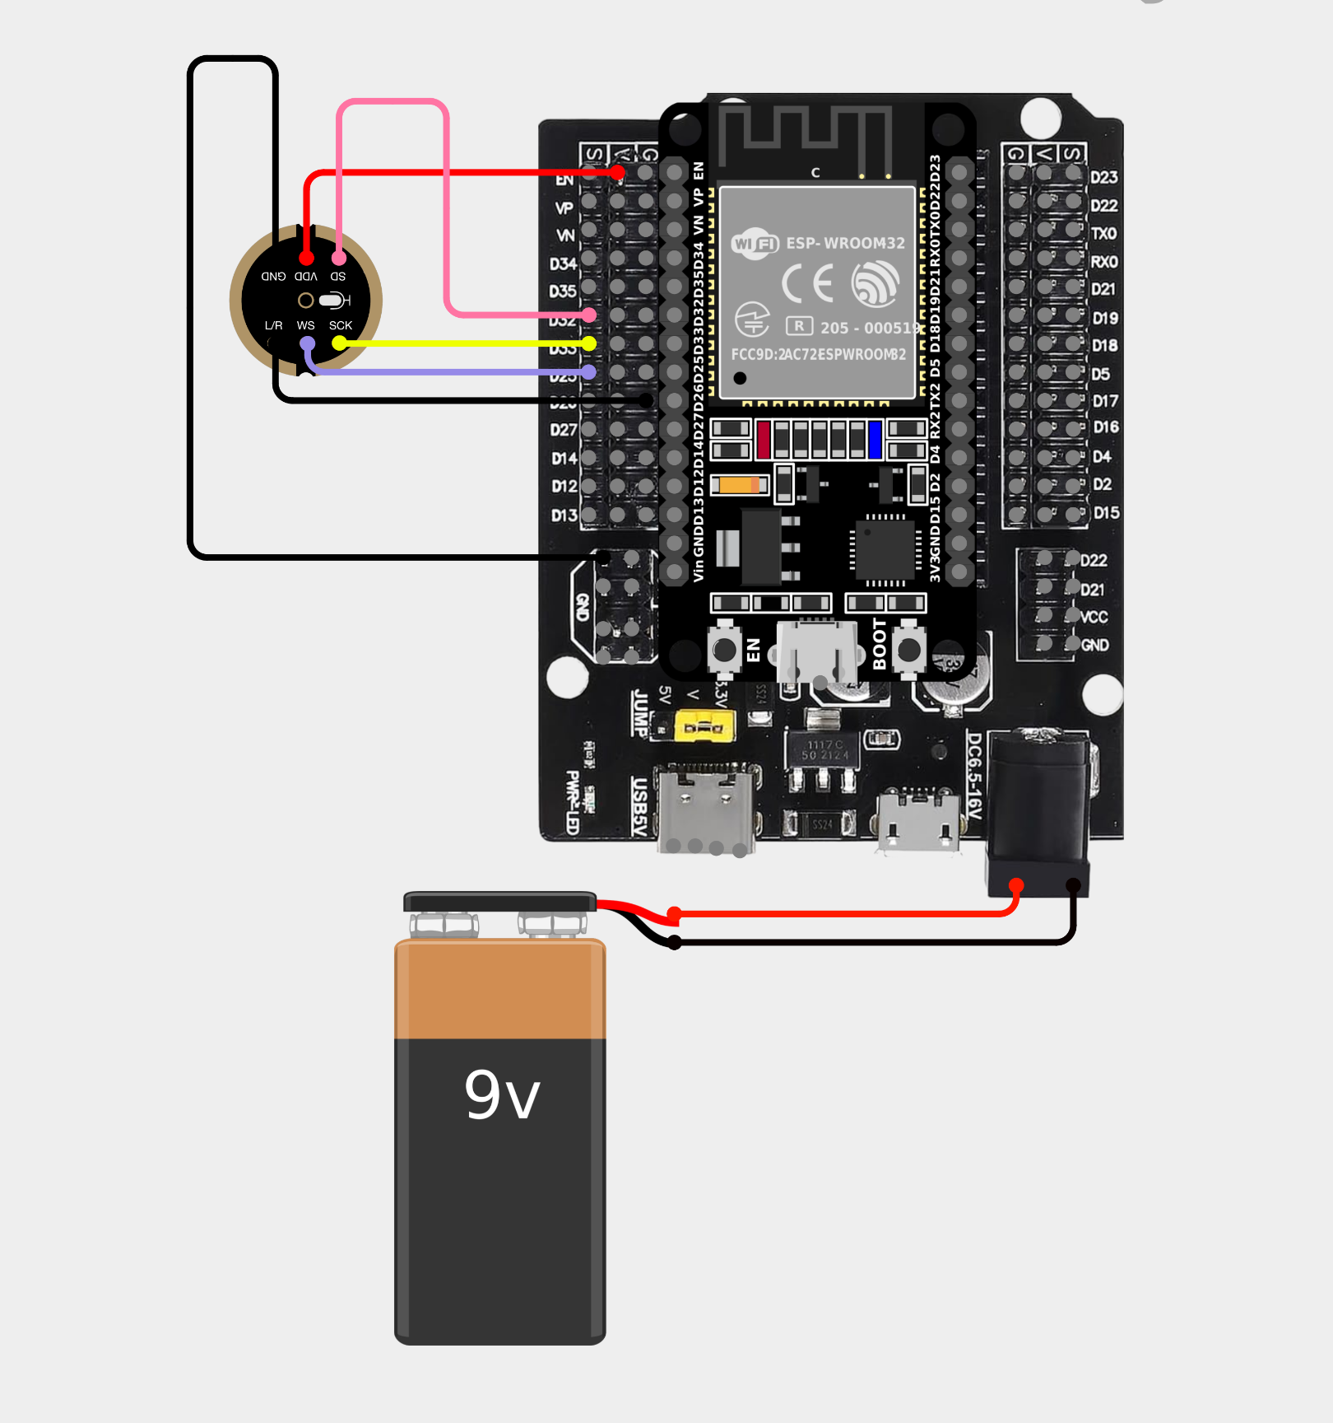
Figure 2. Cirkit Designer Diagram
The physical assembly of the device involves integrating the INMP441 MEMS microphone into a standard acoustic stethoscope and connecting it to the ESP32 microcontroller. Female-to-female jumper wires connect the VCC pin of the microphone to the 3V power supply on the ESP32. Connect both the GND and L/R to a GND pin on the ESP32 using jumper wires. For the data lines, the WS pin is connected to D25, the SD pin to D32, and the SCK pin to D33. This configuration enables the ESP32 to receive digital audio data from the microphone through the I²S interface for processing and uploading to the web server. The device is powered through a USB connection or 9v battery using a snap connector, and all components are securely housed to ensure durability and ease of handling during clinical use. Assembly also includes testing the microphone sensitivity, verifying proper connections, and ensuring that the device is safe for both patients and healthcare workers.

Web Development
Web development focuses on creating a responsive and simple interface for receiving, processing, and displaying lung sound data. The web application is designed to handle incoming audio files uploaded via Wi-Fi from the ESP32 device. It includes features for audio playback, identification of sound, and the presentation of classification results. The server-side implementation ensures efficient handling of data, application of the AI model for analysis, and secure storage of results. Frontend design emphasizes ease of use, allowing healthcare professionals to quickly interpret the AI-generated outputs.

Artificial Intelligence Integration
The AI integration is designed so that anyone can replicate the main device functionality through the website. First, the trained Edge Impulse CNN model is exported and connected to the web application using a standard inference API or JavaScript library. Uploaded or recorded lung sound files are automatically preprocessed on the server or in the browser to match the format used during training, such as converting audio into Mel-spectrograms. The preprocessed data is then passed to the model, which outputs probability scores for each respiratory condition. The website displays these scores in a user-friendly format and handles errors to ensure smooth operation.
vice is also evaluated for user-friendliness, portability, and reliability in clinical or research environments. Any necessary adjustments are made to hardware or software to enhance
Device Finalization
Device finalization is the stage where all components, the microphone, ESP32 microcontroller, and web interface, are tested together to ensure seamless operation. This includes verifying audio quality, Wi-Fi connectivity, real-time data transmission, AI classification accuracy, and proper display of results on the website. The dence performance ensures that the system is ready for deployment in real-world applications.
- RESULTS AND DISCUSSIONS
Table 1. Perceived challenges and needs in diagnosing respiratory diseases (LRTDs) among Barangay Health Workers and Satellite Clinic staff
Category | Essential Themes
Category | Barangay Health Workers (BHWs) | Satellite Clinic Staff
Availability of Diagnostic Tools | Reliance on basic tools (mainly stethoscope); lack of diagnostic devices limits accuracy. | Limited diagnostic equipment; variation in tool quality and availability across facilities.
Training and Knowledge of Health Workers | Need for continuous and practical training in lung assessment and symptom recognition. | Inconsistent training and skill gaps; need for regular refresher and standardized capacity-building.
Environmental and Infrastructural Limitations | Noisy environment and weak signal interfere with assessment; limited physical space. | Overcrowded clinics, poor ventilation, and infrastructure strain hinder efficient diagnosis.
Time Constraints During Consultations | Heavy patient load; multitasking required; short consultation time per patient. | High volume of patients forces quick consultations, affecting diagnostic accuracy.
Referral Systems and Access to Higher-Level Care | Referrals limited by patients’ financial constraints and travel distance. | Hospital congestion and shortage of specialists delay referrals and feedback.
Community Awareness and Health- Seeking Behavior | Low health literacy; misconceptions about respiratory symptoms; need for constant community education. | Poor early consultation habits; reliance on self-medication before seeking formal care.

Table 1 Revised findings revealed that barangay health workers and satellite clinic staff face interconnected challenges in diagnosing respiratory diseases, especially in rural settings. Most rely on basic stethoscopes without confirmatory tools, echoing Ginsburg et al. (2021) on limited diagnostic capacity in primary care. Many expressed uncertainty in lung sound interpretation, consistent with Rowe et al. (2020), who noted inadequate respiratory training among frontline providers. Environmental noise, cramped spaces, and unstable connectivity further hinder auscultation accuracy, as shown by Nalakurthi et al. (2024), who emphasized sensor reliability issues in noisy field conditions. Weak referral systems and financial constraints delay escalation to higher care levels (Harrison & Karim, 2019). Low health literacy and persistent misconceptions also reduce early consultation rates (Adebayo et al., 2020). These barriers, especially prevalent in barangay-based facilities, underscore the urgent need for accessible diagnostic support and continuous training to strengthen respiratory care at the community level.

Histogram 1 highlights the uneven distribution of diagnostic challenges across rural clinics. The most frequently emphasized issue is training gaps affecting confidence, underscoring how limited auscultation skills and misinterpretation risks undermine diagnostic accuracy. This aligns with broader concerns about insufficient diagnostics, where reliance on basic stethoscopes and lack of x ray facilities force early referrals. Environmental and infrastructural barriers, such as poor connectivity, hospital congestion, and background noise, further constrain timely care. While teamwork and collaborative workflows help sustain throughput, they cannot fully compensate for systemic shortages in equipment and expertise. Community awareness also emerges as a recurring theme: misconceptions, low health literacy, and limited outreach delay early care seeking. Overall, the histogram shows that while frontline staff adapt through efficiency and education, the structural deficits in tools, training, and infrastructure remain the most pressing barriers to reliable respiratory disease diagnosis in rural barangay settings.
Table 2. Summary of Prioritized Design Features among Barangay and Satellite Health Workers
Category | Essential Theme | Essential Insights
Form Factor | Ergonomic portability; Pediatric usability | Health workers prefer a compact, lightweight, and pocket-sized device with retractable or longer tubes suitable for children.
Interface Layout | Visual simplicity; Decision support | The GUI should have clear buttons, icons, and visual cues to aid quick judgment and reduce misinterpretation.
Portability | Field readiness; Reliable power | The device must be portable, durable, and usable during emergencies, with rechargeable or flexible power sources.
Maintenance & Cleaning | Hygiene-ready design; Reprocessing | Health workers emphasized waterproof, rust-resistant materials that can be easily disinfected or safely disposed of.
Workflow Compatibility | Seamless embed; Offline reliability | Integration with telemedicine and offline functionality ensures easy adoption in remote barangays.
Cost & Affordability | Cost sensitivity; Price barrier | Devices priced below ₱2,000 are preferred due to tight barangay budgets, ensuring accessibility and sustainability.

Table 2 revealed that barangay and satellite health workers prioritize a device that is compact, user-friendly, and affordable, reflecting the realities of low-resource, community-based healthcare. Consistent with Ginsburg et al. (2021), portability and ergonomic design are essential to enable use in remote or emergency contexts. Workers value simple interfaces and visual clarity, aligning with Rowe et al. (2020), who emphasized usability for varying literacy levels. Ease of cleaning and durability are critical for infection control (World Health Organization, 2021), while offline compatibility supports telemedicine integration amid unstable internet connectivity (Harrison & Karim, 2019). Finally, cost sensitivity remains decisive, as affordability directly influences adoption in barangay settings (Adebayo et al., 2020). Collectively, these findings highlight the need for an accessible, robust, and context-tailored screening device that complements existing workflows and empowers frontline workers to improve respiratory disease detection at the primary care level.
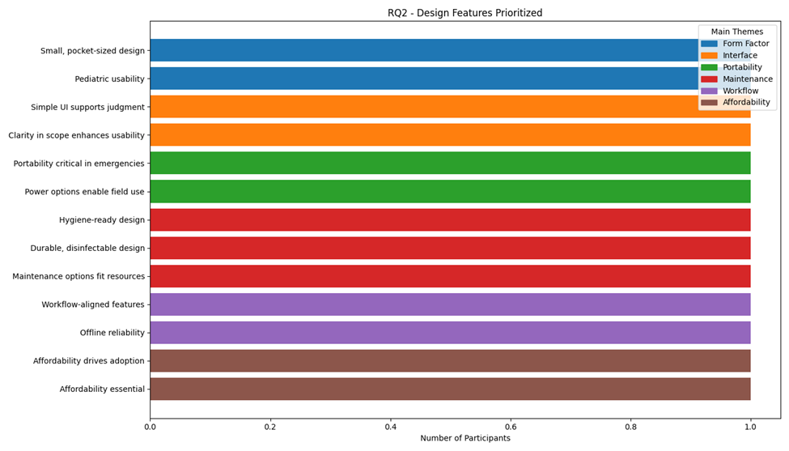
Histogram 2 demonstrates that participants value a broad spectrum of design features, with no single factor dominating. Instead, emphasis is evenly spread across form factor, interface, portability, maintenance, workflow compatibility, and affordability. Portability and offline reliability are critical for emergency and rural use, reflecting the realities of limited connectivity and urgent response needs. Maintenance and infection control also rank highly, with calls for waterproof, wipeable, or disposable components to ensure hygiene in resource constrained clinics. Interface simplicity, through clear buttons and supportive baselines, is seen as essential for nurses with varying digital familiarity. Affordability is a cross cutting concern, with participants setting a threshold of ₱2,000–₱3,000 to ensure adoption by barangay health units. The histogram suggests that SmartSteth’s success depends not on a single “killer feature,” but on balancing practical usability, durability, and cost sensitivity, ensuring the device integrates seamlessly into existing workflows while remaining accessible to underfunded rural clinics.
Table 3. Summary of Frontline Health Workers’ Perceptions on GUI Intuitiveness
Category | Essential Theme | Essential Insights
Ease of Navigation | Straightforward interaction | Buttons and menus should be clearly labeled and logically arranged for quick use during patient consultations.
Clarity of Instructions | Embedded guidance | Built-in user or video guides help minimize confusion, support independent learning, and improve operational accuracy.
Accessibility (Low Literacy) | Inclusive interface | The GUI must accommodate varying digital literacy levels through simple layouts, icons, and optional customization.
Error Prevention | Conservative outputs | The app should emphasize that results are predictive or supportive, not diagnostic, to maintain clinical safety and trust.
Training Time | On-demand learning | Short, accessible modules such as webinars and app-based tutorials promote proficiency among busy or remote health workers.
Multilingual Support | Language inclusivity | Providing multiple language options can enhance accessibility, especially for barangay-based users across diverse regions.

Table 3 reveals that frontline health workers value a simple, clear, and supportive GUI that reduces cognitive load and accommodates varying digital literacy levels. Participants emphasized clear navigation and labeled buttons (KI_03), embedded video or written guides (KI_03), and options suitable for senior or less tech-savvy users (KI_04). These preferences mirror findings in recent usability research, which highlight clarity, consistency, and error prevention as key determinants of user satisfaction in mobile health interfaces (Lim et al., 2025). Similarly, an umbrella review underscored the importance of plain language, visual cues, and intuitive navigation in improving accessibility for low-literacy users (BMC Medical Informatics & Decision Making, 2024). Evidence from wearable health technologies in low-resource contexts also stresses the value of training support and user-friendly layouts for adoption and trust (Nakaggwa et al., 2024). Collectively, these affirm that SmartSteth’s GUI must prioritize simplicity, guidance, and inclusivity to ensure effective frontline use.

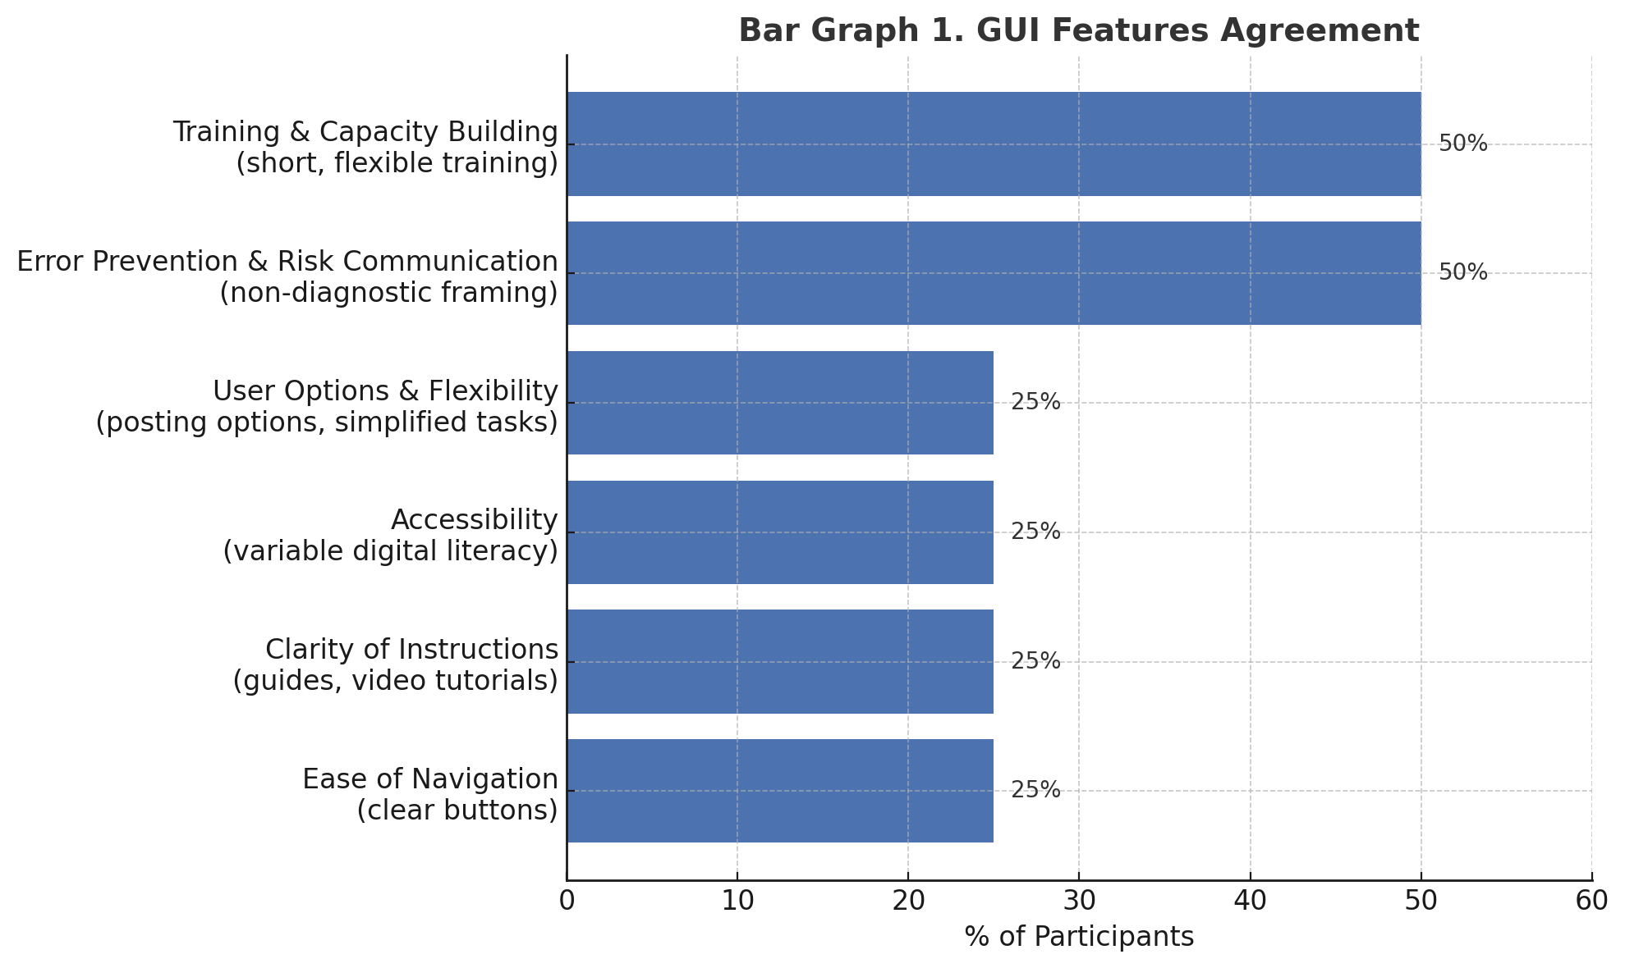
Bar Graph 1 indicates that frontline health workers expressed varied but converging preferences for a graphical user interface (GUI) that is simple, supportive, and adaptable to different levels of digital literacy. Individual participants emphasized distinct needs: clear navigation and labeled buttons (KI_03), embedded video or written guides (KI_03), options for less tech-savvy or senior users (KI_04), and customizable posting features (KI_01). Two participants underscored the importance of non-diagnostic framing to prevent misuse (KI_03, KI_04) and flexible training formats such as webinars (KI_02, KI_03). Although consensus was limited in this small sample, the themes collectively highlight the importance of reducing cognitive load, providing guidance, and accommodating heterogeneous user skills. These findings align with broader evidence that clarity, consistency, and error prevention drive usability in mobile health applications (Lim et al., 2025), while plain language, visual cues, and training support improve accessibility and adoption in low-resource contexts (BMC Medical Informatics & Decision Making, 2024; Nakaggwa et al., 2024).

Table 5. Key Performance Metrics for Evaluating SmartSteth’s Efficiency
Metric | Evaluation Method | KPI / Target | Relevance
Signal-to-Noise Ratio (SNR) | Bench and field recordings under variable noise | ≥20 dB (quiet), ≥10 dB (field) | Ensures clear auscultation and accurate AI detection
Frequency Resolution | FFT analysis (50–2000 Hz) | ≥5–10 Hz resolution | Enables precise identification of respiratory sounds
Latency | Time from input to AI output | 2 ms | Supports real-time decision-making
Sensitivity to Sound Types | Comparison with expert-labeled dataset | ≥85% sensitivity; F1 ≥ 0.83 | Indicates diagnostic reliability
Robustness to Noise | Controlled and field noise testing | ≥80% sensitivity at 5–10 dB SNR | Confirms usability in real environments
Consistency Across Profiles | Stratified performance analysis | ≤10% variance | Promotes equity and generalizability

Table 5 reveals that SmartSteth’s efficiency in respiratory sound screening relies on achieving an optimal balance between signal clarity, diagnostic sensitivity, and robustness under real-world conditions. A high signal-to-noise ratio (≥20 dB) and frequency resolution of 5–10 Hz enable accurate detection of respiratory sounds such as wheezes and crackles, aligning with recent advances in digital auscultation and deep-learning stethoscope systems (Huang et al., 2023; Lee et al., 2025). Low latency (2 ms) supports real-time clinical use, consistent with the performance of wearable stethoscopes designed for automated diagnosis (Science Advances, 2024). Robustness at 5–10 dB SNR addresses ambient noise challenges frequently observed in community and low-resource settings (Journal of Global Health, 2025; Lee et al., 2025). Maintaining ≥85% sensitivity and an F1-score ≥ 0.83 across diverse sound types ensures diagnostic reliability comparable to current state-of-the-art AI classifiers (Xie, Zhou & Xu, 2025). Moreover, consistent performance across pediatric and adult profiles promotes inclusivity and diagnostic fairness, essential for equitable healthcare delivery. Collectively, these indicators establish a robust and evidence-based framework for assessing SmartSteth’s diagnostic readiness and practical utility in primary-care and resource-limited environments.

Table 6. Factors Influencing Acceptance and Trust in SmartSteth
Category | Essential Theme | Essential Insights
Perceived Usefulness & Reliability | Conditional trust; Adjunct utility | Health workers value SmartSteth as a decision-support tool that enhances assessment accuracy, but long-term trust depends on consistent AI performance and validated results.
Cultural Compatibility & Relevance | Adaptation to local practice | Acceptance relies on gradual transition from manual to digital methods and clear communication of the device’s role within diverse cultural and community settings.
Previous Experience with Digital Tools | Familiarity-driven confidence | Users with prior exposure to digital or telemedicine tools express higher trust and willingness to integrate SmartSteth into their workflow.
Community Endorsement & Peer Influence | Social validation | Endorsements from local leaders, medical missions, or peer demonstrations strengthen confidence and encourage adoption among barangay workers.
Transparency of Diagnostic Results | Role clarity; Clear scope | Explicitly stating that SmartSteth provides supportive—not definitive—findings fosters responsible use and maintains respect for physician authority.
Support & Training Provided | Structured capacity-building | Continuous access to webinars, manuals, and orientation sessions empowers users, promotes confidence, and reinforces sustained acceptance.

Table 6 reveals that SmartSteth’s acceptance and trust hinge on reliability, transparency, cultural fit, and ongoing training. Health workers emphasized the need for consistent AI accuracy and contextual validation before integrating new tools, consistent with findings by Tun et al. (2025), who reported that reliability and explainability are core to trust in AI-driven diagnostics. Transparent communication of results and maintaining physician oversight further support ethical use, echoing the conclusions of O’Sullivan et al. (2024) on clinician-AI collaboration. Cultural alignment and community endorsement remain critical, as supported by Nakaggwa et al. (2024), who found localized outreach essential for mHealth adoption in low-resource settings. Finally, structured, short-format training improves confidence among digitally novice users, aligning with Lim et al. (2025), who highlighted training accessibility as a determinant of usability and trust in mobile health applications.
Table 7. Comparative assessment of SmartSteth and E-Steth across key design and usability categories
SmartSteth | Categories | E-Steth
Simple, icon-based interface; easy for low-digital users. | Interface and Usability
  Requires internet and higher digital literacy.
Pocket-sized, rechargeable, works offline. | Portability and Offline Use | Needs stable internet; less field-ready.
Waterproof, rust-resistant, easy to disinfect. | Maintenance and Cleaning | Harder to clean; complex build.
Fits barangay workflows; supports offline use. | Fit with Existing Workflows in Rural Clinics | Designed for hospitals; network-dependent.
 | Cost and Affordability for Community Health Facilities | Expensive (₱15k–₱40k); less accessible.
  Costs under ₱2,000; locally built and affordable.
Table 7 shows that SmartSteth offers substantial advantages over E-Steth in design, usability, and affordability. Its icon-based interface promotes ease of use among health workers with low digital literacy, improving accessibility and efficiency. The device’s pocket-sized, rechargeable, and offline-capable design enhances portability and reliability in rural areas with poor connectivity. Its waterproof, rust-resistant build allows easy disinfection, supporting hygienic use in field conditions. Seamless integration with barangay workflows and offline data management enables continuous patient monitoring even in remote communities. Priced under ₱2,000, SmartSteth is significantly more affordable than imported digital stethoscopes, promoting equitable access to diagnostic tools. Overall, these results highlight SmartSteth’s practicality and potential to improve respiratory disease screening in low-resource settings by addressing usability, cost, and environmental limitations.

CONCLUSION

This study affirms the feasibility and value of deploying AI-assisted auscultation tools like SmartSteth in rural and barangay-level health settings. By leveraging convolutional neural networks to analyze respiratory sounds, SmartSteth addresses longstanding diagnostic challenges faced by frontline health workers, including limited training, environmental interference, and the absence of confirmatory equipment. The device demonstrated strong usability and diagnostic support, particularly in contexts where traditional auscultation is constrained by noise, space limitations, and unstable connectivity.

Feedback from barangay health workers revealed increased confidence in lung sound interpretation and a clear demand for ongoing training and workflow integration. However, systemic barriers, such as weak referral systems, financial constraints, and low health literacy, continue to impede timely care and reduce early consultation rates. These findings underscore the importance of pairing technological innovation with capacity building and community engagement.

SmartSteth offers a scalable, context-sensitive solution to improve respiratory screening and empower frontline providers. Its integration into local health systems has the potential to reduce diagnostic disparities and promote equitable access to data-driven care in underserved communities.

ACKNOWLEDGMENT
The researchers' would like to express their profound gratitude and appreciation to the following individuals for their contributions, unwavering support with no cost on their part to complete this study: Ma. Regina P. Bravo, Dr. Ricardo B. Panganiban, Allan Paul Caabay, RN, MSN, John Lester Zamora, RN, the researchers' parents, and above all, to the almighty and heavenly Father.

REFERENCES
Acta Medica Philippina. “Clinical Profile and Prescribing Patterns of Therapy in Children with Bronchial Asthma in a Rural Site in the Philippines: A Retrospective Cohort Study.” Last modified 2023. https://actamedicaphilippina.upm.edu.ph/index.php/acta/article/view/8536..
Ginsburg, A. S., J. Delarosa, and E. Nkwopara. “Improving Respiratory Disease Diagnosis in Low-Resource Settings: The Role of Digital Auscultation.” Global Health Science and Practice 8, no. 4 (2020): 728–737. https://doi.org/10.9745/GHSP-D-20-00245..
International Journal of Infectious Diseases. “Etiology and Epidemiology of Community-Acquired Pneumonia in Adults Requiring Hospital Admission: A Prospective Study in Rural Central Philippines.” Last modified 2019. https://doi.org/10.1016/j.ijid.2018.12.005..
Medtigo Journal. “Prevalence of Bronchiolitis in Children up to Two Years of Age Presented to Tehsil Headquarter Hospital Dogar, Central Kurram.” Last modified 2023. https://journal.medtigo.com/prevalence-of-bronchiolitis-in-children-up-to-two-years-of-age-presented-to-tehsil-headquarter-hospital-dogar-central-kurram/..
Minttihealth. “SmartSteth: AI-Powered Auscultation for Rural Diagnostics.” Last modified 2024. https://www.minttihealth.com/smartsteth-ai-auscultation/..
Philippine Health Association. “Urban-Rural Disparities in Diagnostic Access: A National Health Systems Review.” Last modified 2025. https://www.pha.gov.ph/research/urban-rural-diagnostic-access..
Philippine News Agency. “DOH Warns of Possible Rise in Pneumonia Cases among Children.” Last modified 2024. https://www.pna.gov.ph/articles/1211234..
World Health Organization. Primary Health Care in Rural and Remote Settings: Bridging the Gap. Last modified 2021. https://www.who.int/publications/i/item/primary-health-care-rural-remote..
Zhang, Y., H. Li, and X. Chen. “Convolutional Neural Networks for Respiratory Sound Classification: A Comparative Study.” Journal of Biomedical Informatics 135 (2023): 104236. https://doi.org/10.1016/j.jbi.2023.104236..

APPENDIX A
RAW DATA (RESULTS)

Interview transcript – Sicsican Clinic
- Researchers: Kiesha Mekhaela B. Relatado, Teokislev Gazelle J. Jompella
- Participant code: SC-P01
- Date of interview: September 30, 2025
- Location of interview: Barangay Sicsican Clinic
List of acronyms:
- AI — Artificial Intelligence
- CHO — City Health Office
- URTI — Upper Respiratory Tract Infection
- BP — Blood Pressure
- IT — Information Technology

Transcript
(00:05)
Kiesha Mekhaela B. Relatado: Hello po. Yung age, optional lang po. Gagamitin po namin yung pangalan niyo sa research.
Kiesha Mekhaela B. Relatado: What is your age?
SC-P01: 34.
Kiesha Mekhaela B. Relatado: Profession?
SC-P01: Nurse.
Kiesha Mekhaela B. Relatado: Years of experience in healthcare?
SC-P01: Almost 4 years.
(00:43)
Kiesha Mekhaela B. Relatado: Yung study po namin ay tungkol sa SmartSteth. AI-powered stethoscope po siya na nagre-record ng lung sounds at nagsa-submit sa website para ma-predict ang most likely respiratory illness.
Kiesha Mekhaela B. Relatado: Target po namin ay rural areas, kaya po kami nandito sa Barangay Sicsican. User acceptance po ang focus ng interview.
(01:32)
Kiesha Mekhaela B. Relatado: What difficulties do you face when identifying respiratory symptoms in the community?
SC-P01: Depende sa brand ng stethoscope at sa positioning. Pero mostly, okay naman.
(02:00)
Kiesha Mekhaela B. Relatado: How does limited training or knowledge affect your confidence in recognizing these diseases?
SC-P01: Para sa iba, possible na mamisinterpret ang findings—lalo na kung hindi masyadong naririnig ang lung sounds.
(02:37) Kiesha Mekhaela B. Relatado: How do time constraints or environmental barriers like poor ventilation or lack of electricity affect diagnosis?
SC-P01: Wala namang malaking difference. Pero kapag maingay ang paligid, doon nagkakaproblema—may ibang sounds na pumapasok sa stethoscope.
(03:13)
Kiesha Mekhaela B. Relatado: What device features would make it easier to use in the field—like simplicity, clarity, icon-based interface?
SC-P01: Since rural ang target, dapat offline-capable. Maraming lugar walang internet.
(03:46)
Kiesha Mekhaela B. Relatado: As of now, online pa siya. Pero plan po namin na maging offline-capable ang device.
SC-P01: Okay. Kasi sa far-flung areas, mahirap talaga pag walang internet. Manual pa rin ang gamit doon.
(04:35)
Kiesha Mekhaela B. Relatado: Kung ima-mass produce po namin ang device, sa tingin niyo po matatanggap siya ng medical community?
SC-P01: Possible. Makakatulong siya sa medical professionals. Pero dapat consistent ang AI updates.
(05:15)
Kiesha Mekhaela B. Relatado: Given na maraming Filipinos ang nagse-self-diagnose, how do you encourage families in Sicsican to seek help?
SC-P01: Ina-advise namin sila na mag-consult sa health center. Kung hindi kaya dito, nire-refer namin sa City Health o preferred hospital.
(06:23) Kiesha Mekhaela B. Relatado: How important is portability, battery life, and ease of transport in your daily work?
SC-P01: Important siya, lalo na sa emergency cases. Dapat mabilis madala ang pasyente sa facility.
(06:48)
Kiesha Mekhaela B. Relatado: What level of affordability would make the device accessible for Barangay Sicsican?
SC-P01: Medyo tight ang budget ng barangay. Usually, City Health ang nagbibigay ng equipment sa designated midwife.
(07:20)
Kiesha Mekhaela B. Relatado: Sa tingin niyo po, ano ang price range na tatanggapin ng barangay?
SC-P01: Depende sa budget. May sample na ba kayo ng device—like picture or prototype?
(08:19)
SC-P01: Wala pa po as of now. Kakabili lang namin ng microphone sa Manila. Gagawin pa lang yung product.
Kiesha Mekhaela B. Relatado: May design na po ba kayo?
SC-P01: Opo, may picture na kami ng design.
(08:51)
SC-P01: Para may pagpipilian sa posting, para mas madali sa users.
SC-P01: We’re maintaining affordability. We’re just integrating AI.
(09:26)
Kiesha Mekhaela B. Relatado: Ganito lang talaga siya kaliit?
SC-P01: Opo. Didikit sa patient. Portable. Depende sa microcontroller.
SC-P01: Parang pocket size. Retractable yung tube—nahihila-hila.
(09:51)
SC-P01: Budget namin sa project is around ₱3,000.
Kiesha Mekhaela B. Relatado: Sa tingin niyo po, ano ang acceptable price range?
SC-P01: Less than ₱2,000. Pero kung marami siyang features, okay lang. Basta consistent ang updates.
(10:39)
Kiesha Mekhaela B. Relatado: How do you think the community will respond to a digital diagnostic tool like SmartSteth?
SC-P01: I can explain its purpose to healthcare professionals.
SC-P01: Depende kung magshi-shift sila from manual to digital—like BP apparatus, may manual at digital.
SC-P01: Kung saan comfortable at efficient, doon sila mag-aadjust.
(11:17) Kiesha Mekhaela B. Relatado: Sa tingin niyo po, magiging skeptical sila dahil AI-based?
SC-P01: Hindi naman siguro. Diagnosis pa rin ng doktor ang basehan.
(11:40)
Kiesha Mekhaela B. Relatado: What role does cultural compatibility play in acceptance?
SC-P01: Malaking tulong ito.
Kiesha Mekhaela B. Relatado: How important is endorsement from community leaders?
SC-P01: Pwede mag-conduct ng orientation or medical missions para ma-endorse ang device. Para maging aware ang community.
(12:44)
Kiesha Mekhaela B. Relatado: Ano pong advice niyo sa design? Kailangan po ba mahaba ang tube?
SC-P01: Yes. Especially sa children—agitated sila pag natatouch.
SC-P01: Mahaba ang tube para hindi madamage ang device.
SC-P01: Concise size, complete features. May chip or memory card?
(14:04)
Kiesha Mekhaela B. Relatado: Microcontroller po siya—wireless transmission to website.
SC-P01: Okay. Pero kung offline, mas maganda kung may memory card.
Kiesha Mekhaela B. Relatado: Possible po ‘yan.
(14:22)
Kiesha Mekhaela B. Relatado: What are the most urgent needs for improving respiratory disease diagnosis in your setting?
SC-P01: May nagpapacheck-up naman. Mostly URTI, cough and colds.
SC-P01: Babies are hard to auscultate—di mo sila mapapahinga ng malalim.
(15:21)
SC-P01: Kung may noise cancellation, mas makakatulong. Focused sa internal lung sounds.
(15:43) Kiesha Mekhaela B. Relatado: Final advice for SmartSteth developers?
SC-P01: Continue improving the device.
SC-P01: After release, conduct pilot testing. Address priority issues first.
SC-P01: Hindi lahat ng problems mare-resolve agad. Piliin ang pinaka-importante.
(16:46)
SC-P01: Depende pa rin sa IT team kung sabay-sabay i-address ang issues.
(17:04)
Kiesha Mekhaela B. Relatado: Prevalent po ba ang respiratory illnesses sa Sicsican?
SC-P01: Depende sa weather. Ubo pag maulan.
Kiesha Mekhaela B. Relatado: What about communicable diseases like asthma or pneumonia?
SC-P01: Minsan, community-acquired pneumonia—lalo na kung exposed sa secondhand smoke.
(17:56)
Kiesha Mekhaela B. Relatado: Wala na pong ibang nurse dito?
SC-P01: Ako lang po. Yung midwife naka-leave.
Kiesha Mekhaela B. Relatado: Kayo lang po may experience sa diagnosis?
SC-P01: For now, yes.

Interview Transcript – Salvacion Clinic
- Interviewer: Teokislev Gazelle J. Jompella
- Participant code: SV‑P01 (Registered Nurse, 25 years old, ~2 years in healthcare)
- Date of Interview: October 5, 2025
- Location of Interview: Barangay Salvacion Clinic
List of acronyms:
- AI — Artificial Intelligence
- CHO — City Health Office
- URTI — Upper Respiratory Tract Infection
- BP — Blood Pressure
- IV — Intravenous
- GUI — Graphical User Interface
(00:00)
Teokislev Gazelle J. Jompella: Edad niyo po?
SV‑P01: Edad? 25.
Teokislev Gazelle J. Jompella: Propesyon?
SV‑P01: Registered nurse.
Teokislev Gazelle J. Jompella: Ilang taon na po kayo sa healthcare?
SV‑P01: Dalawang taon.

(01:39)
Teokislev Gazelle J. Jompella: Paano niyo po nababalanse ang dami ng pasyente at time constraints sa konsultasyon?
SV‑P01: Isa-isa lang ang pasyente. Dumadami sila, pero dahil marami kami sa duty, nagtutulungan kami.
SV‑P01: Hindi naman siya burden kahit busy. Sanay na kami, lalo na kung may doktor. Talagang teamwork.
(02:34)
Teokislev Gazelle J. Jompella: Ano po ang mga challenges kapag nagpaparefer kayo sa ospital o espesyalista?
SV‑P01: Una, problema sa signal. Pangalawa, maraming requirements ang private hospitals.
SV‑P01: Minsan walang available na kama. Kaya kadalasan, sa Palawan Hospital napupunta ang pasyente.
SV‑P01: May pagkakataon na may dalawa akong critical na pasyente—isa mababa ang BP, isa posibleng may heart attack.
SV‑P01: Wala kaming gamot para itaas ang BP. Wala ring IV fluids. Kailangan pa naming maghanap sa ibang barangay.
SV‑P01: Iba-iba rin ang requirements ng bawat doktor bago tumanggap ng pasyente.

(05:16)
Teokislev Gazelle J. Jompella: Ano pa po ang ibang gaps na nakikita ninyo?
SV‑P01: Health education pa rin. Kailangan maintindihan ng pasyente at pamilya ang kondisyon.
Teokislev Gazelle J. Jompella: May problema po ba sa pag-inform sa komunidad?
SV‑P01: Dahil satellite clinic lang kami, hindi kami lumalabas. Ibang sector ang humahawak niyan.
SV‑P01: Kami ang humahawak ng emergency cases dito sa area.

(06:12)
Teokislev Gazelle J. Jompella: Paano po dapat i-design ang device para madaling linisin at i-maintain sa rural clinics?
SV‑P01: Dapat madaling linisin—spray o swab na hindi makakaapekto sa microphone.
SV‑P01: Mas maganda kung may protective layer ang stethoscope at ang box, lalo na sa paligid ng mic.
SV‑P01: Para maiwasan ang maling diagnosis.
(09:42)
Teokislev Gazelle J. Jompella: Anong klaseng interface layout ang makakatulong sa mga nurse na limitado ang digital training?
SV‑P01: Education pa rin ang susi. Maganda kung may webinars o face-to-face training.
Teokislev Gazelle J. Jompella: Paano po ma-integrate ang device sa kasalukuyang patient care routines nang hindi nakakadagdag ng burden?
SV‑P01: Dapat ready-to-use. Pero sana may offline mode, kasi hindi lahat ng lugar may signal.
SV‑P01: Kahit offline, dapat accurate pa rin.
(11:56)
Teokislev Gazelle J. Jompella: Paano nakakaapekto ang dating karanasan mo sa digital tools sa willingness mong gumamit ng smart devices?
SV‑P01: Para sa akin, madali lang. Medyo inclined kami sa ganitong tech.
SV‑P01: Pero yung mga senior nurses, nahihirapan—lalo na sa internet, logins, passwords. Nakakaubos ng oras para sa kanila.
(13:43–13:58)
SV‑P01: Medyo maingat ako. Gusto ko munang matest ang device sa maraming lugar—hindi lang isa. (13:58–14:19)
SV‑P01: Para makita kung consistent ang performance. Paano kung mahina ang signal dito? Doon mo malalaman kung talagang reliable ang device.
(14:19–14:44)
Teokislev Gazelle J. Jompella: Paano niyo po ipapaliwanag ang resulta ng device sa pasyente at pamilya para magkaroon sila ng tiwala?
SV‑P01: Kung gumagana nang maayos ang device, ipapaliwanag ko ito kasabay ng signs and symptoms ng pasyente.
SV‑P01: Base pa rin ako sa physical assessment. Add-on lang ang device sa initial findings.
(15:20–15:49)
Teokislev Gazelle J. Jompella: Sa pagbabalik-tanaw, ano po sa tingin ninyo ang pinaka-kagyat na pangangailangan para mapabuti ang diagnosis ng respiratory diseases sa setting ninyo?
SV‑P01: Health education pa rin. Kulang ang outreach ng gobyerno—lalo na sa mga liblib na lugar.
(16:09–16:47)
SV‑P01: Pinaka-epektibo ang house-to-house teaching. Nakakatulong din ang flyers.
SV‑P01: May mga tribal areas din dito—mahalagang maipaliwanag nang malinaw sa kanila.
(16:47–17:12)
Teokislev Gazelle J. Jompella: Anong payo ang maibibigay ninyo sa mga developer ng SmartSteth para mas maging tanggap at kapaki-pakinabang ito sa komunidad ninyo?
SV‑P01: Dapat accessible kahit offline. Dapat accurate ang results. I-promote pa para malaman ng mga tao.
(17:38–18:02)
SV‑P01: May mga ganitong device na—tulad ng Lipman. Hindi na bago sa amin. Pero kailangan pa ring palawakin ang kaalaman.
(18:02–18:34)
SV‑P01: Kailangan pa ng mas maraming research. Dahil bago pa ito, may duda pa rin. Kailangan ninyong patunayan ang sarili ninyo. Offline access ang susi.
(18:34–18:59)
SV‑P01: Hindi dapat nakakaubos ng oras. Dapat may protective layers ang device—lalo na sa toxic cases kung saan natatapon ang gamit.
(18:59–19:22)
SV‑P01: Dapat may charger at port. Kung may website, dapat may guiding questions din.

Interview Transcript – Macarascas Clinic
- Interviewer: Teokislev Gazelle J. Jompella
- Participant code: MC‑P01 (Clinic staff)
- Date of Interview: September 30, 2025
- Location of Interview: Barangay Macarascas Clinic
List of acronyms:
- AI — Artificial Intelligence
- CHO — City Health Office
- URTI — Upper Respiratory Tract Infection
- BP — Blood Pressure
- IEC — Information, Education, and Communication
- TB — Tuberculosis
- GUI — Graphical User Interface
- ONP — Ospital ng Palawan
- COPD — Chronic Obstructive Pulmonary Disease
- ECG — Electrocardiogram
(00:17)
Teokislev Gazelle J. Jompella: Ano po yung pinaka urgent or pressing needs po dito na na-encounter nyo sa pagda-diagnose ng respiratory diseases?
MC‑P01: Kami po, hindi nagda-diagnose—doktor po ang gumagawa nun.
MC‑P01: For check-ups, meron kaming stethoscope, pero wala kaming x‑ray.
MC‑P01: Basic lang po talaga dito sa clinic. Kung hindi kaya, referral agad sa hospital.
(01:55)
MC‑P01: Teamwork po kami. Usually 2–3 ang naka-duty. Hati‑hati sa tasks.
MC‑P01: May triage kami—pagdating ng pasyente, kinukuha agad ang vitals, tapos forward sa amin.
MC‑P01: Kami ang nagsusulat ng complaints, tapos diretso na sa doktor.
MC‑P01: Kailangan mabilis, kasi kung mabagal, aabutin ka ng gabi.
MC‑P01: May specific task assignments para efficient ang flow.
(03:20)
Teokislev Gazelle J. Jompella: Ano po yung mga challenges nyo pag nagpaparefer sa hospital?
MC‑P01: Una, capacity. Apat lang ang hospital—tatlo private, isa public.
MC‑P01: Sa private, problema agad ang financial aspect.
MC‑P01: Karamihan dito sa poor sector, kaya sa public hospital kami umaasa.
MC‑P01: Pero napupuno rin ang provincial hospital, lalo na sa peak season.
MC‑P01: Kapag puno ang private, tinatapon nila sa ONP. ONP, being government, tatanggapin kahit puno—pero hindi agad maaasikaso. (04:37)
MC‑P01: Hangga’t kaya sa satellite level, minamanage namin.
MC‑P01: Pero kung critical, wala nang choice—takbo na sa ONP.
MC‑P01: ONP can’t refuse, pero hindi rin agad maasikaso dahil sa dami ng referrals from other municipalities.
(05:49)
Teokislev Gazelle J. Jompella: Paano nyo po na-address ang community misconceptions?
MC‑P01: Sa barangay health centers, sila ang preventive side—kasama ang IEC.
MC‑P01: Dito sa amin, kapag admitted na, part na ng management ang education.
MC‑P01: Pagdating nila dito, may sakit na sila—so hindi na preventive, kundi curative na.
(06:49)
Teokislev Gazelle J. Jompella: Nagde-develop po kami ng screening or pre-diagnostic device. Paano po dapat i-design ang device para madaling linisin at i-maintain sa rural clinics?
MC‑P01: Dapat waterproofed.
(07:11)
MC‑P01: Hindi mo alam kung anong klaseng pasyente ang darating—lalo na sa respiratory cases. May TB patients na sumusuka ng dugo.
MC‑P01: Dapat waterproof ang material. May plema, dugo—hindi mo alam.
MC‑P01: Mahirap kung absorbent ang material. Hindi puwedeng i-autoclave ang microphone. Hindi rin puwedeng hugasan.
MC‑P01: Dapat rust‑resistant. Basic alcohol lang ang disinfectant.
MC‑P01: Mas okay kung may plastic cover—parang sa ultrasound probe. Pero dapat walang effect sa sound quality.
MC‑P01: Infection control ang priority sa medical devices.
(09:19)
Teokislev Gazelle J. Jompella: How important is the interface for nurses with limited digital training?
MC‑P01: Pwede ba siya sa cellphone?
Teokislev Gazelle J. Jompella: May microcontroller po sa loob, tapos wirelessly connected sa website.
MC‑P01: Maganda kung app‑based. Mas accessible.
MC‑P01: Pero dapat may video guide—lalo na sa staff na hindi tech‑savvy.
MC‑P01: Hindi lahat makaka‑attend ng training. Sa amin, walo kami pero hindi sabay‑sabay.
MC‑P01: Mas okay kung may user guide sa app.
MC‑P01: Younger staff prefer reading, pero older staff hindi na nagbabasa.
(11:53)
Teokislev Gazelle J. Jompella: How can the device be integrated into current patient care routines?
MC‑P01: Hindi siya burden. Part ng basic assessment ang auscultation—lalo na kung may ubo o sipon.
MC‑P01: Mas maganda kung may mic na nagre‑record ng sound.
MC‑P01: Helpful kung puwedeng i‑download at i‑send sa doktor via Messenger—lalo na kung walang doktor on‑site.
MC‑P01: Pwede sa telemedicine. May mga digital stethoscope na ganito, pero mahal.
MC‑P01: Sana may option to download or share via link—parang iCloud. Kahit link lang, para ma‑share ang sound file.
(14:02)
MC‑P01: Sound ang importante—crackles, wheeze.
MC‑P01: Doktor ang mas particular sa tunog.
MC‑P01: Machine may error risk.
MC‑P01: Kahit walang interpretation, basta ma‑record ang tunog, kaya na naming i‑interpret.
(15:36)
Teokislev Gazelle J. Jompella: Ito po ang main design at testing ng model.
MC‑P01: May AI na nag‑analyze gamit ang dataset from credible sources.
MC‑P01: Pero mabigat ang salitang “diagnosis.”
MC‑P01: Dapat “early warning” lang—para ma‑refer agad sa doktor.
MC‑P01: Halos magkakapareho ang lung sounds ng pneumonia, asthma, etc.—kailangan pa rin ng x‑ray.
(16:34)
Teokislev Gazelle J. Jompella: Model shows confidence level based on 20,000 audio recordings (5 seconds each).
(17:12)
Teokislev Gazelle J. Jompella: Output is automatic—e.g., asthma.
MC‑P01: Machine compares new audio to dataset and outputs most similar result.
MC‑P01: AI analyzes and suggests possible diseases related to wheezing.
MC‑P01: Pero hindi dapat umasa agad sa diagnosis.
MC‑P01: Minsan may wheeze and crackles combined—iba’t ibang interpretation.
(17:21)
MC‑P01: AI ang nag‑a‑analyze. Pero dapat naka‑encapsulate lang yung output—suggestive of possible diseases related to wheezing.
MC‑P01: Hindi dapat agad i‑diagnose as asthma. Minsan may wheeze at crackles combination.
MC‑P01: May upper and lower lung sounds—iba‑iba. Minsan may “no lung sound” kung puno ng tubig or hangin.
(18:53)
MC‑P01: Tama rin na “respiratory audio classifier” ang tawag—hindi “disease classifier.”
MC‑P01: Pwede lumabas na “wheeze sound detected, may be suggestive of asthma.”
MC‑P01: COPD, asthma, etc.—magkakapareho ang tunog. Kaya dapat suggestive lang. (19:35)
MC‑P01: Maganda ang idea, pero mabigat kung “diagnosis” ang label. Parang ECG—hindi nagsasabi ng sakit, kundi rhythm lang. Kapag abnormal ang rhythm, saka ka pa‑e‑evaluate.
(20:25)
MC‑P01: Suggestion: panel outputs like “wheeze detected,” “no sound,” etc.
MC‑P01: Kahit isa lang ang ma‑detect, okay na.
MC‑P01: Output like “wheeze sound detected, may suggest asthma, please consult…” is helpful.
(21:16)
MC‑P01: Sound detection is key—whizz, crackles, etc.
MC‑P01: Whizz = asthma. Crackles = parang tunog ng hair scratch.
MC‑P01: GUI is helpful—buttons should be clear. It’s another way to confirm findings.
(22:49)
MC‑P01: Pwede bang iwan lang ang stethoscope sa pasyente? Traditional method requires presence.
MC‑P01: Pwede ipatong lang, pero kailangan pa rin i‑guide ang pasyente.
MC‑P01: Machine can compile 5‑second audio chunks and compute results.
(23:49)
MC‑P01: Mas okay kung less contact—lalo na sa infectious cases. Parang sa COVID, may patch‑style stethoscope.
MC‑P01: Pwede rin removable or detachable parts—para lusot sa contamination risk. (25:20)
MC‑P01: Material ng vest dapat waterproof—like nylon. Pwede i‑connect sa cords, detachable setup.

Interview Transcript – San Rafael Clinic
- Interviewer: Kiesha Mekhaela B. Relatado
- Participant code: KI_04 (Registered midwife; Registered nurse; 30 years old; ~8 years in healthcare)
- Date of Interview: September 30, 2025
- Location of Interview: Barangay San Rafael Clinic
List of acronyms:
- AI — Artificial Intelligence
- CHO — City Health Office
- URTI — Upper Respiratory Tract Infection
- BP — Blood Pressure
- GUI — Graphical User Interface
- IEC — Information, Education, and Communication
- IP — Indigenous Peoples

Transcript
(0:00–0:08)
Kiesha Mekhaela B. Relatado: Sige, magsimula tayo. Puwede ko bang gamitin ang pangalan mo? Optional lang. Kung ayaw mo, okay lang.
(0:09–0:21)
Kiesha Mekhaela B. Relatado: Puwede ba? Okay lang. Edad mo, ma’am?
KI_04: 30.
Kiesha Mekhaela B. Relatado: Propesyon?
KI_04: Registered midwife, registered nurse.
(0:22–0:40)
Kiesha Mekhaela B. Relatado: Ilang taon ka na sa healthcare?
KI_04: Ngayon, 8 years na akong nasa serbisyo. Pero bilang midwife, mahigit 10 years na.
Kiesha Mekhaela B. Relatado: Okay.
(0:41–1:24)
Kiesha Mekhaela B. Relatado: Unang tanong: Ano po ang pinaka-kagyat na pangangailangan na nae-encounter ninyo sa pag-diagnose ng respiratory diseases sa barangay clinic ninyo?
KI_04: Kagyat na pangangailangan? Sa tingin ko, kakulangan sa kagamitan. Dahil nasa rural area kami, hindi lahat may access sa facilities. Kaya ang gamit namin ay basic lang para ma-assess ang pasyente.
(1:25–2:06)
KI_04: Iyon lang ang magagamit namin.
Kiesha Mekhaela B. Relatado: Okay. Paano niyo nababalanse ang dami ng pasyente at time constraints sa konsultasyon?
KI_04: Actually, nababalanse naman... Kapag maraming pasyente, lalo na kung may doktor, naka-duty kami ng 3 araw. Give and take—kung sino ang available, kung sino ang unang hahawak sa pasyente—doon kami nagma-manage.
(2:07–2:20)
KI_04: Timing talaga ang usapan diyan.
Kiesha Mekhaela B. Relatado: Okay. Ano po ang mga challenges sa pag-coordinate ng referral sa ospital o espesyalista?
KI_04: Challenges? Marami.
(2:21–3:03)
KI_04: Sa government facilities, ang challenge ay walang specialist. Kaya kung may pasyente na kailangan ng specific na doktor, minsan hindi nila kaya. Hindi namin sila mapilit—choice nila ‘yon, pero malaking issue ang financial capability.
(3:04–3:33)
KI_04: Sa private hospitals, dati kapag tumawag kami para sa referral, okay agad. Pero ngayon, kailangan munang hintayin ang acceptance nila—kahit nasa pagitan ng buhay at kamatayan ang pasyente. Hindi namin sila mapilit kung ayaw tanggapin ng ospital.
(3:34–4:06)
KI_04: Sa mga IPs (Indigenous Peoples), madalas takot sila sa tao o kulang sa kaalaman. Kahit payuhan namin na magpa-transport, mas gusto nilang umuwi.
(4:07–5:03)
Kiesha Mekhaela B. Relatado: Paano niyo hinaharap ang mga maling paniniwala ng komunidad tungkol sa respiratory illnesses?
KI_04: Sa pamamagitan ng health teaching. Sa komunidad, maraming misconceptions. Kaya sa konsultasyon, bukod sa medical advice, nagbibigay kami ng health teaching—kung ano ang dapat gawin, ano ang dapat unahin.
(5:03–5:41)
KI_04: Halimbawa, health teaching kung talagang kailangan ng pasyente.
(5:51–6:19)
Kiesha Mekhaela B. Relatado: Ipapakita namin sa inyo ang TD model ng device namin. Heto siya. Ito ang set—may LED na umiilaw, halimbawa sa upper left. Sa loob, may microcontroller na nakakonekta sa phone app.
(6:19–6:40)
Kiesha Mekhaela B. Relatado: I-develop namin ito base sa advice ng healthcare workers. Gusto nila marinig ang lung sounds sa phone. Ito ang tanong namin.
(6:42–7:28)
Kiesha Mekhaela B. Relatado: Paano dapat i-design ang device para madaling linisin at i-maintain sa clinic ninyo?
KI_04: Katulad ng ibang device—pagkatapos gamitin, i-disinfect. Kung disposable, itapon. Kung reusable, linisin nang maayos.
Kiesha Mekhaela B. Relatado: Okay. Anong layout ng interface ang makakatulong sa mga nurse na limitado ang digital training?
KI_04: Ano ibig sabihin nun?
Kiesha Mekhaela B. Relatado: Ibig sabihin, design ng interface ng device.
(7:28–8:05)
KI_04: Katulad ng mga nurse na nakausap namin—maraming senior nurses ang hindi techy. Hindi ko masabi, kasi sa clinic namin, lahat marunong gumamit. Uma-attend kami ng trainings at seminars. Siguro sa seniors, hindi ko masasabi para sa kanila.
Kiesha Mekhaela B. Relatado: Okay.
(8:23–9:02)
Kiesha Mekhaela B. Relatado: Paano ma-integrate ang device sa kasalukuyang patient care routines nang hindi nakakadagdag ng burden?
KI_04: Puwede naming ipaliwanag ang proseso at advantages ng device. Marunong naman sila—kailangan lang ipaliwanag nang maayos.
(9:02–9:11)
Kiesha Mekhaela B. Relatado: Okay. GUI. GUI.
KI_04: GUI. Oo.
(9:11–9:27)
Kiesha Mekhaela B. Relatado: Ito ang dalawang klase ng device namin.
(9:27–9:45)
Kiesha Mekhaela B. Relatado: Ito ang original design. Para sa testing kung gumagana talaga ang model. Dito makikita ang confidence ng model sa pag-predict ng type ng disease.
(9:46–9:57)
Kiesha Mekhaela B. Relatado: Base sa tunog. Iyon ang pinapakita namin sa model. Dito makikita ang graphical user interface, ang GUI.
(9:58–10:19)
Kiesha Mekhaela B. Relatado: Kapag binago ang screen, makikita ang user interface. Iyon ang karaniwang nakikita ng user kapag binuksan ang website. Halimbawa, kung gagamitin sa pasyente, puwede nitong i-classify kung healthy, may pneumonia, bronchitis, o asthma.
(10:20–10:29)
Kiesha Mekhaela B. Relatado: Depende sa tunog—base sa output ng stethoscope pagkatapos ng auscultation. Tapos may warning.
(10:30–10:36)
Kiesha Mekhaela B. Relatado: Hindi ito final diagnosis. Prediction lang. (10:37–10:46) KI_04: Oo, prediction lang. Warning lang. Check-up lang.
(10:46–10:57)
Kiesha Mekhaela B. Relatado: Ganito siya. Base sa dataset, pareho sa tunog sa loob. Iyon ang pinapakita namin sa model.
(10:57–11:04)
Kiesha Mekhaela B. Relatado: Pareho lang. Ito ang GUI. Makikita ang mga buttons.
(11:04–11:11)
Kiesha Mekhaela B. Relatado: Puwede kang mag-upload ng files. Puwede mong i-classify ang audio. Kapag na-classify, lalabas ang percentage.
(11:12–11:20)
Kiesha Mekhaela B. Relatado: Mas madaling maintindihan ng user kasi graphical—hindi lang numbers o words.
(11:21–11:51)
Kiesha Mekhaela B. Relatado: Visual siya. Ito ang pinapakita namin. Gaano ka-accessible ang GUI

APPENDIX B
STATISTICAL DATA (RESULTS)
Table 1. Participant Profile Summary

Participant Code | Profession | Gender
SC-PO1 | Barangay Nurse | Male
SV-PO1 | Satellite Clinic Nurse | Female
MC-PO1 | Satellite Clinic Nurse | Female
KI-04 | Midwife/Satellite Clinic Nurse | Female

Table 2. Diagnostic Tools Mentioned
Tool | Frequency Mentioned
X-ray | 6
GeneXpert | 4
Microscope | 3
Ultrasound | 2
MI | 2

APPENDIX C
SmartSteth Fritzing Diagram

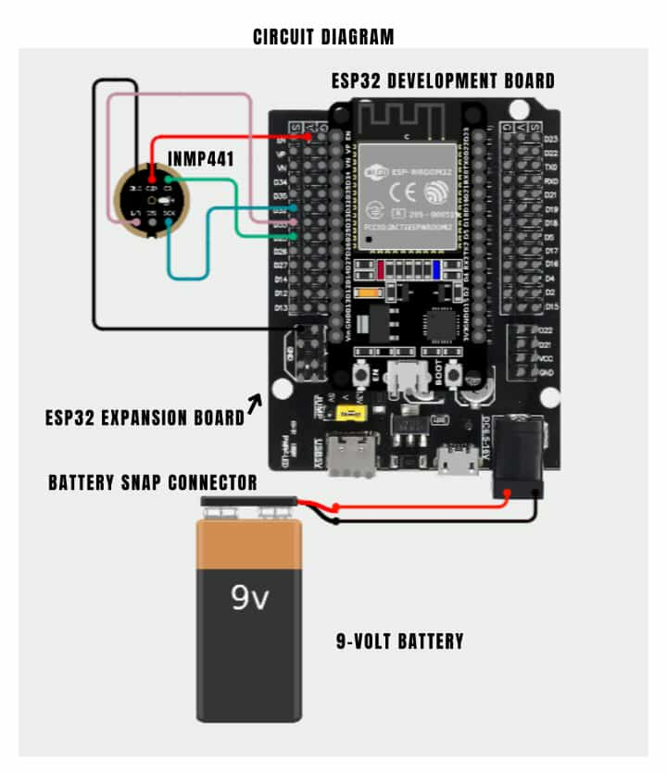

APPENDIX D
Circuit Diagram of the Prototype Device
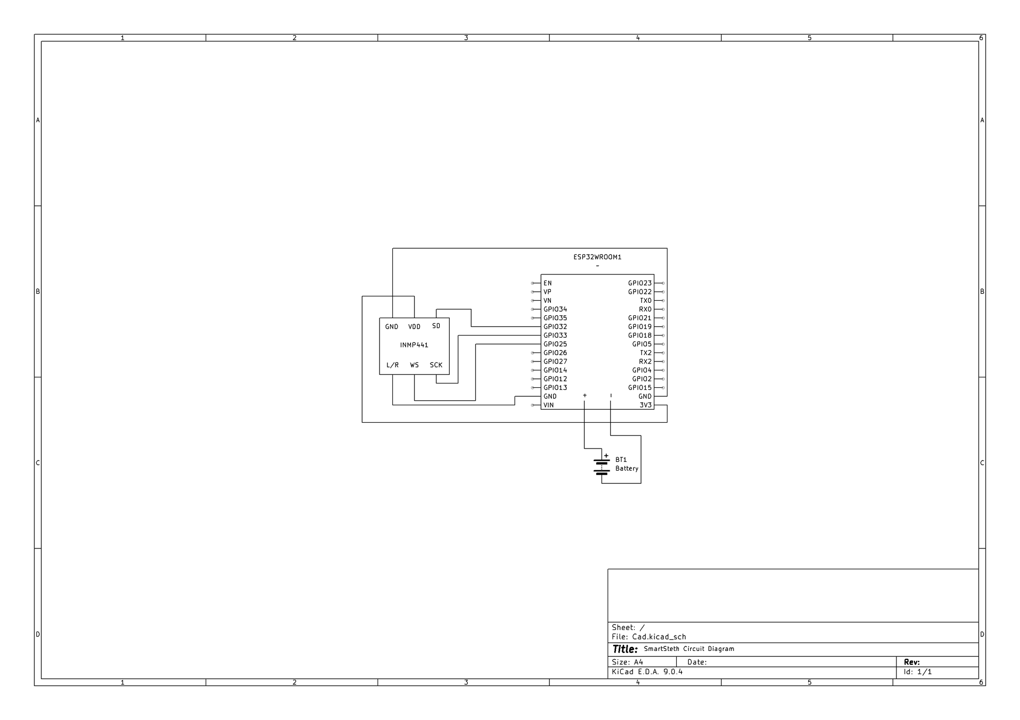

APPENDIX E
Programing Flow Chart of the Prototype Device
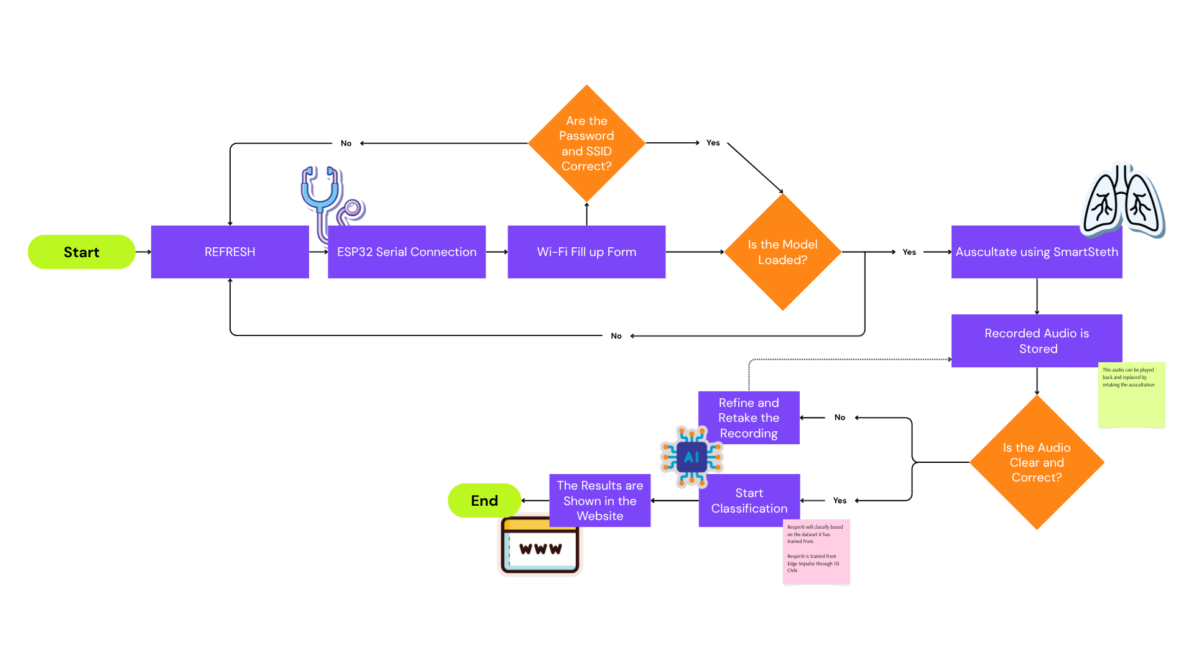

APPENDIX F
3D Model of the Prototype Device

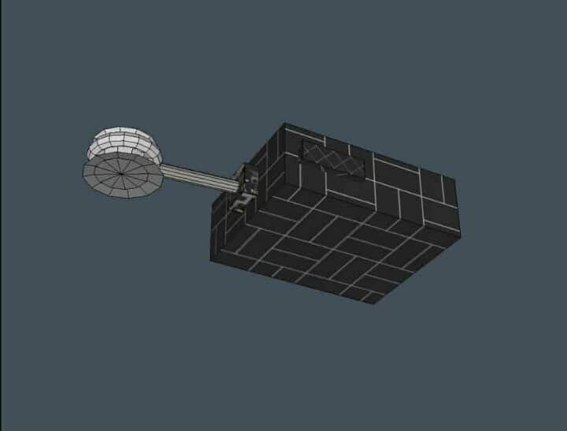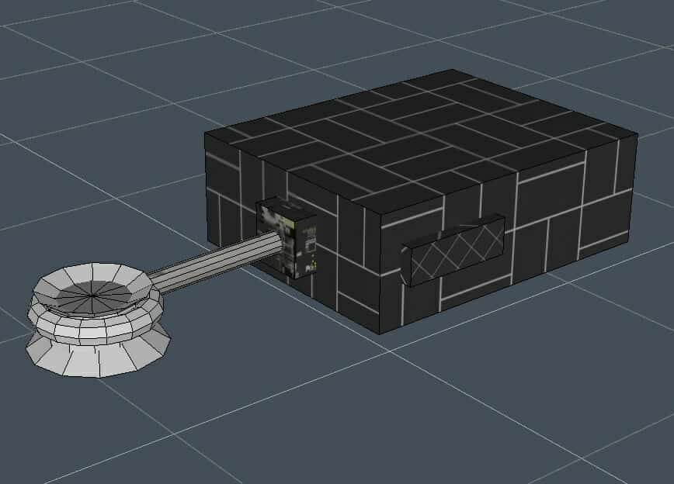

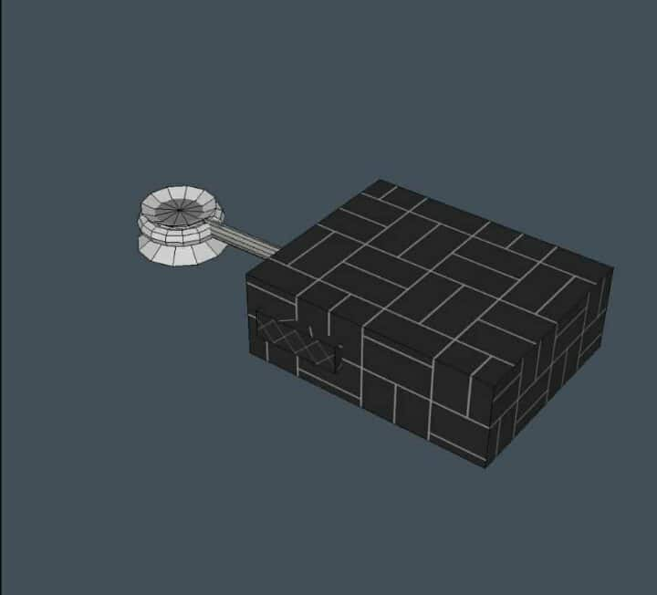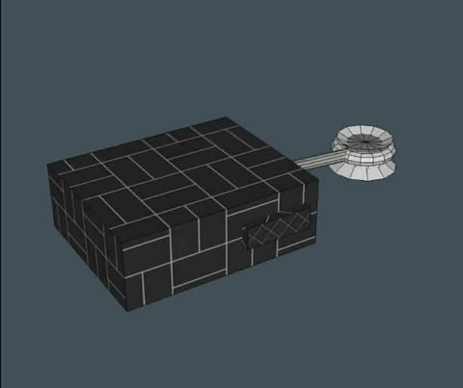

APPENDIX G
Actual Prototype of the device

APPENDIX H
Letters
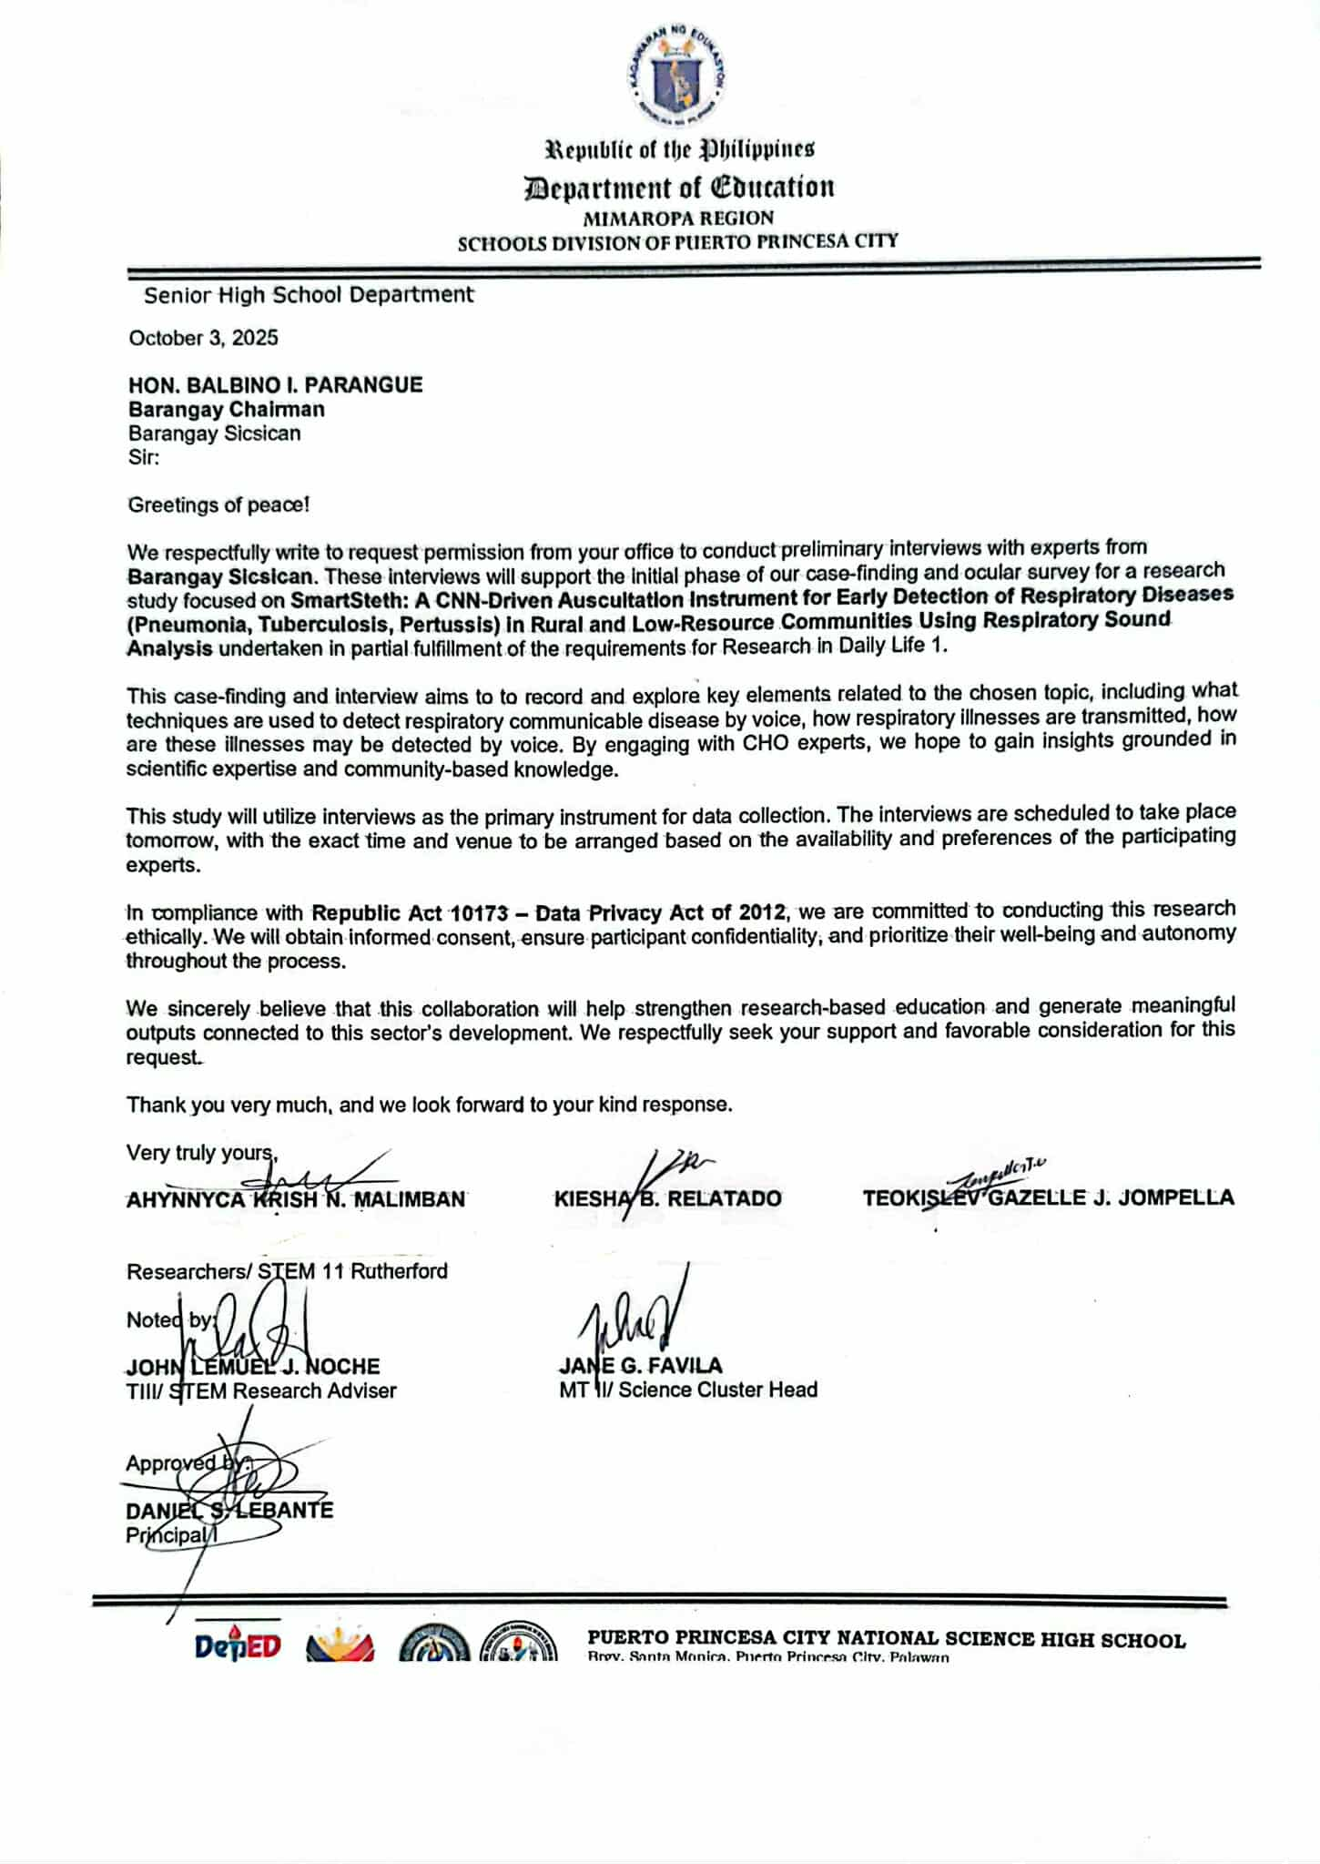

APPENDIX H
Letters
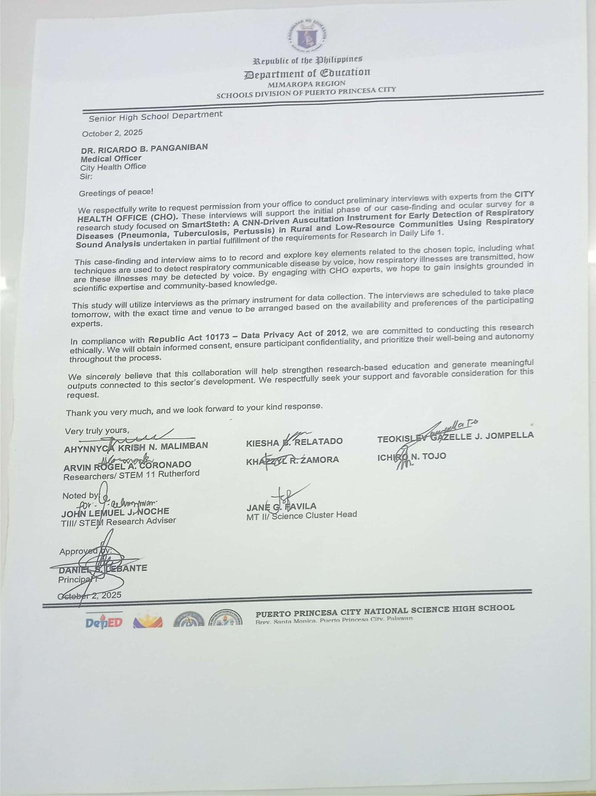
APPENDIX H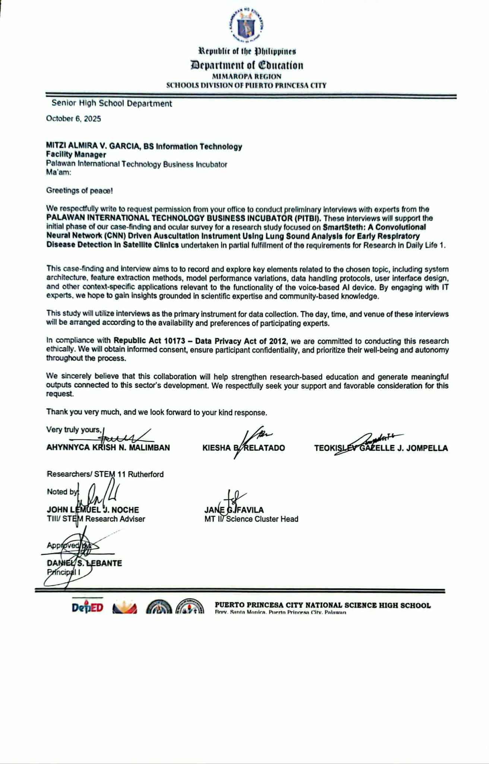
APPENDIX I
Certification

APPENDIX J
Other Documentations



